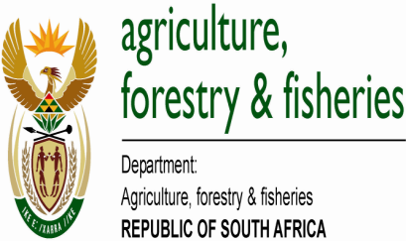
DEPARTMENT OF AGRICULTURE, FORESTRY AND FISHERIES 2017 #YAFF AWARDS PROCESS FLOW
- Nominations open from 01 Feb –30April 2018
- Printable form obtainable on www.daff.gov.za
- Completed forms must be scanned and emailed to #YAFFAwards@daff.gov.za
- Relevant supporting documents must accompany the nomination form
NOMINATION
PHASE 1 PHASE 2 PHASE 3 PHASE 4 PHASE 5
AWARDS CEREMONY IN JUNE 2017
JUDGING
VERIFICATION
INTERNAL SCREENING

- Intensive judging process by an experienced, credible and independent panel of judges

- Judgingof all shortlisted entries using a 100 point based scoring system
- Site visits conducted to verify provided information

- Capturing of video footages

- Short presentation by finalists
- Applications trimmed down to three entries per category

- Undertaken by internal technical team over a period of three days

