INTERNSHIP PROGRAMME FOR THE FINANCIAL YEAR 2018/19
The National Heritage Council (NHC) invites applications for Internship opportunities that the NHC is offering for 2018/2019. The Internship Programme will run for a period of 12 months.
Requirements: Unemployed graduates who have successfully completed a three (3)-year Degree or National Diploma in any field specified below and who are between the ages of 18 and 35 years may apply. Students that still need to finish or qualify for a Degree or National Diploma should not apply.
The NHC is an equal opportunity affirmative action employer. Qualifying people with disabilities are encouraged to apply.

Monthly stipend:R7,500.00 per month
Application forms should be accompanied by a CV, certified copies of qualifications/certificates and a certified copy of a bar-coded South African identity document.
Forward all required documentation to hr@nhc.org.za
Correspondence will be limited to short-listed candidates only. If you have not been contacted within 3 months after the closing date, please consider your application as unsuccessful.

The following are the Internship opportunities that currently exist within the NHC:
 | 1.Office of the Company Secretary and General Counsel  REF:06  Qualifications:  LLBDegree  Number of opportunities:1 |  | No work experience required  This programme will give exposure and provide skills and competence development in the following Functional areas:  - Organisational Ethics  - Drafting of legal documents  - Corporate Governance  - Company Secretariat fiduciary duty, roles and functionality  - Company Law  - Compliance Monitoring  - Company Law
 | 2. Liberation Heritage Unit  Ref: 07  Qualifications:  Honours Degree  Majors in Political Science Anthropology/History/Sociology/  Number of opportunities: 1 |  | - No work experience required or previous internship programme required  - Exposure to multi –media  - Report writing  - The Internship Programme in the NHC is meant to provide the successful candidate with an opportunity to further develop their research expertise by working with subject experts and project specialists.
 | 3. Funding Unit  Ref: 08  Qualifications:  3-year Degree/ Diploma in  Business Administration/ Financial management degree  Number of opportunities: 1 |  | - No work experience required or previous internship required  - Analyse specific funding trends and patterns  - Report writing  - Knowledge of financial management  - Knowledge of legislative /Compliance matters

Please note the following:
Applicants should not have had previous formal employment related to their field of study.
Only candidates who have not previously benefited from an Internship programme will be considered.

The National Heritage Council will not make provision for transport and/or accommodation to any candidate, whether traveling from or outside Gauteng Province.
The NHC will not provide accommodation for any appointed candidate from or outside of Gauteng.
Closing date for the application is 16 February 2018.

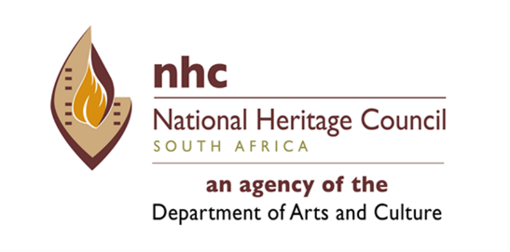

APPLICATION FOR INTERNSHIP
A. THE INTERNSHIP POST
Position for which you are applying:
B. PERSONAL INFORMATION
Surname
First names
Date of birth
Identify number
Race | African | White |  | Coloured |  | Indian
Gender |  |  |  | Female |  | Male
Do you have a disability? |  |  |  | Yes |  | No
If yes indicate the nature of your disability
Have you been convicted of a criminal offence? |  |  |  | Yes |  | No
C. HOW DO WE CONTACT YOU
Telephone number during office hours
Preferred method for correspondence | Post |  | E-mail |  | Fax
Correspondence contact details (in terms of above correspondence)
DECLARATION
I declare that all the information provided (including any attachments) is complete and correct to the best of my knowledge.
Signature: | Date:

