EDS ONLINE INSTRUCTIONAL GUIDE

The eds onlineis an electronic learning environment that is used by SBL students and staff for communication and assignment submission purposes. The basic functionally of the edsonlineconsists of:
- General SBL announcements;
- Programmeannouncements;
- Module specific announcements;
- Assignment submissions; and
- Other communication tools, such as chat facilities, podcasts, etc. which are specific to some SBL modules

Minimum requirements to use theeds online

To use the eds online you must have a working internet connection.
The following browsers are recommended:
- IE 11
- Safari 7+
- Firefox 29+
- Chrome 35+

Unisa and SBL technologyenvironments

As a registered Unisa student you automatically have access to the MyUnisa environment. The MyUnisa environment is used by SBL students for administrationpurposes such as examinationcentre changes, name updates, etc.The support desk contact details for the MyUnisa environment, MyLife, etcare:(+27) 11 471-2256 oremail : MyUnisaHelp@unisa.ac.za
The eds online is primary used for teaching and learning (lecturer communication, study notes, assignment submission, course communication, etc.) by SBL students.
To use any of these two environments you must be a registered student for the relevant academic year.

[Updated 22 April 2016]

The support desk contact details for the MyUnisa environment, MyLife, etc. is: (+27) 11 471-2256 or email: MyUnisaHelp@unisa.ac.za

For any support for the eds online, please send an email to both the following email addresses: moloi.isaac@gmail.com; and seboyk1@unisa.ac.za or call 011 652 0289.

The walk-in eds online Support Desk is situated at the SBL, office 3-34

The maximum resolution time for an eds online query is 48 working hours and any complaints can be forwarded to marriag@unisa.ac.za

Claiming your Unisa Account

As a new student, you must claim your Unisa account (http://my.unisa.ac.za/). Doing this will provide you access to MyUnisa, MyLifeemail account (a life-long email account used by Unisa and the SBL for communication purposes) and Unisa library systems.
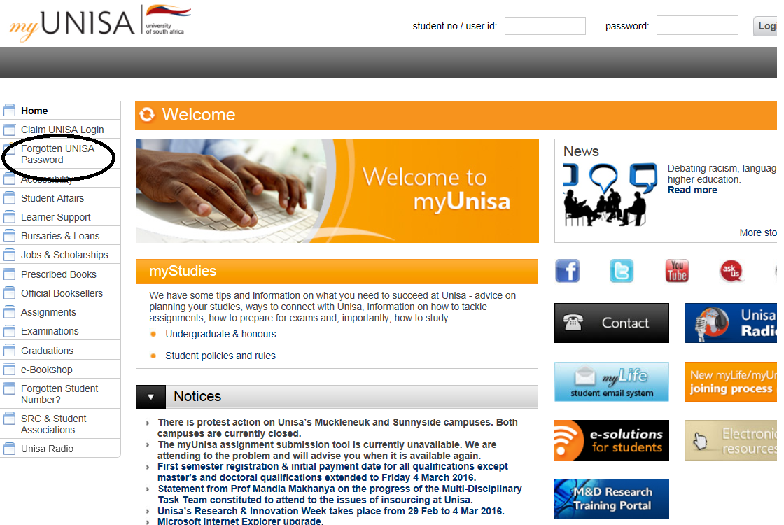
One the web page indicated above, you can reset your MyUnisa password.

Accessing theeds online

To access the eds online, goto http://www.sbleds.ac.za
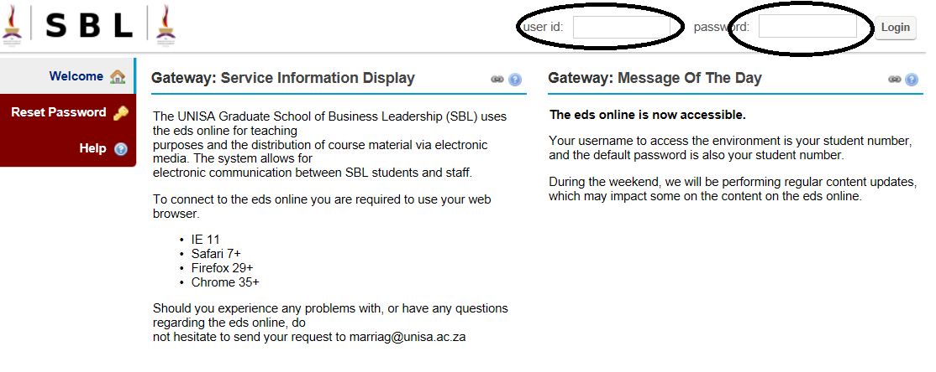
When accessing for the very first time, your username and password is your student number.
If you reset your password on this screen, a link will be sent to your MyLife Unisa account.
However, if you require a password reset for the eds online, and you do not have access to the MyLife email account, then please send an email toMyUnisaHelp@unisa.ac.za

Entering theeds online Main Page

The screen below shows you an example of what you should see when logged into the eds online
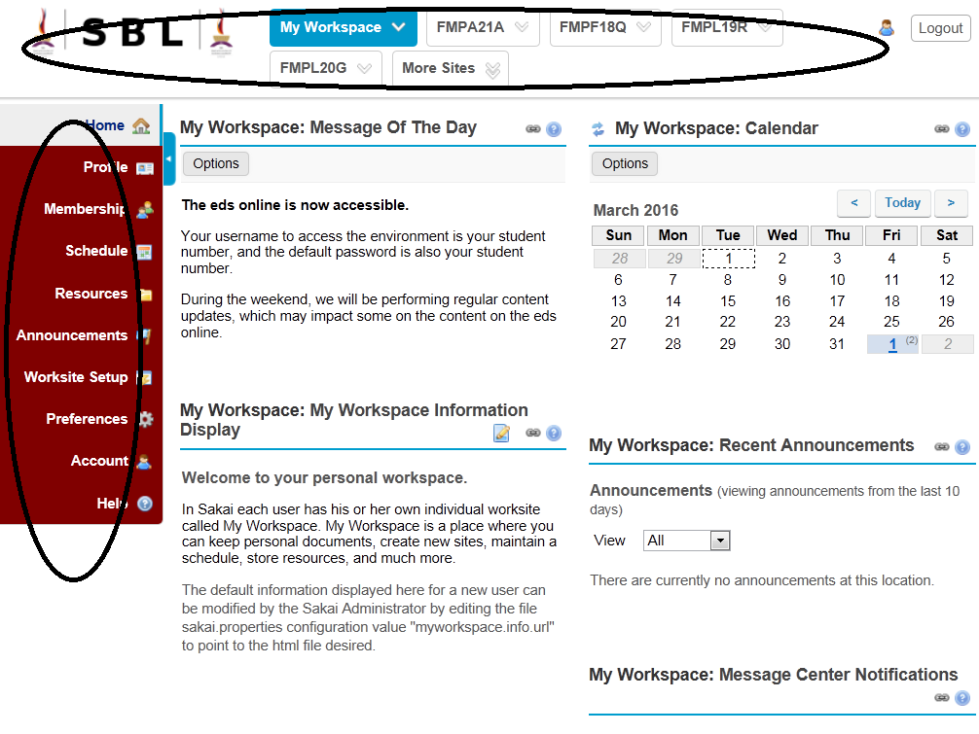

Thebar at the top of the page typically displaysdifferent spaces that you have access to on the eds online. In the example above “My Workspace” is displayed. On the left- hand side the list of items (Profile, Membership, etc.) changes as you select the different buttons on the bar at the top of the page. For example, clicking on “FMPA2A1” will change the list of menu buttons on the left-hand side. The links on the left hand side may also differ depending on the programme that you areregistered for.

Entering a specific module

For example, when clicking on a module such as “FMPA2A1”, the left-hand menu changes to display a list of actions that are relevant to a module.

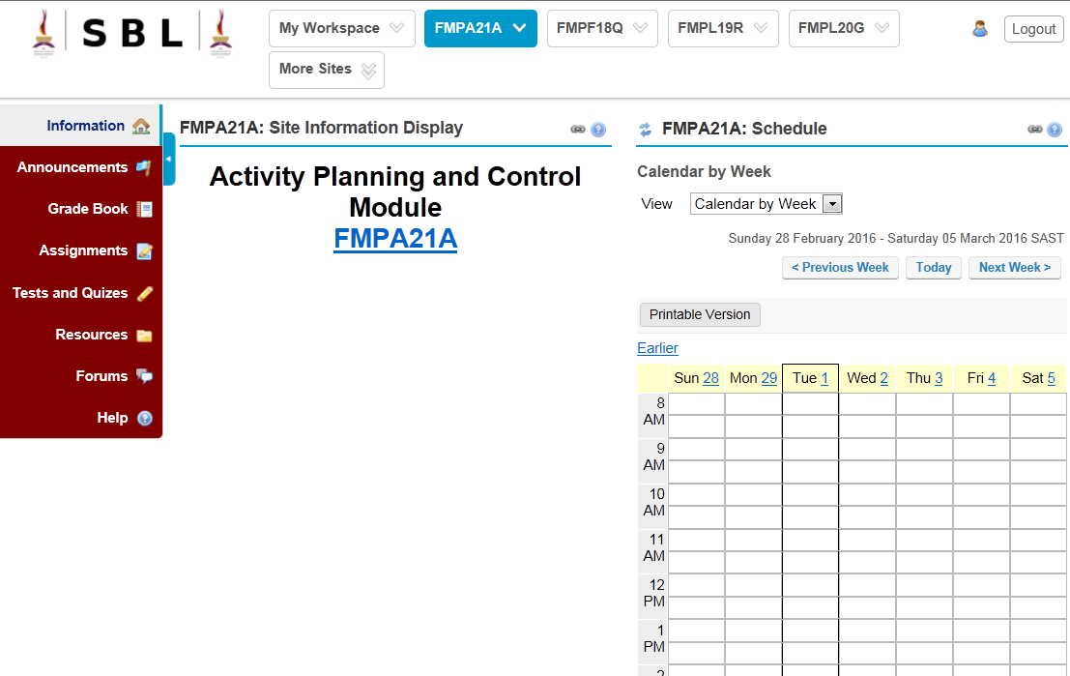

In this case, “Information”, is generic introductory information
- “Announcement”: Announcements relevant to the module
- “Grade Book”: A link to you assignment results after marking and moderation
- “Assignments”: An area to submit completed assignments
- “Testsand Quizzes”: An areawhere a lecturermight post additional tests or quizzes
- “Resource”: An area where you will find your student guide, additional reading material, etc.
- “Forums”: An area whereyou can post or read discussionsrelevant to the module
- “Help”: Where you can find context related assistance on the page you are viewing

