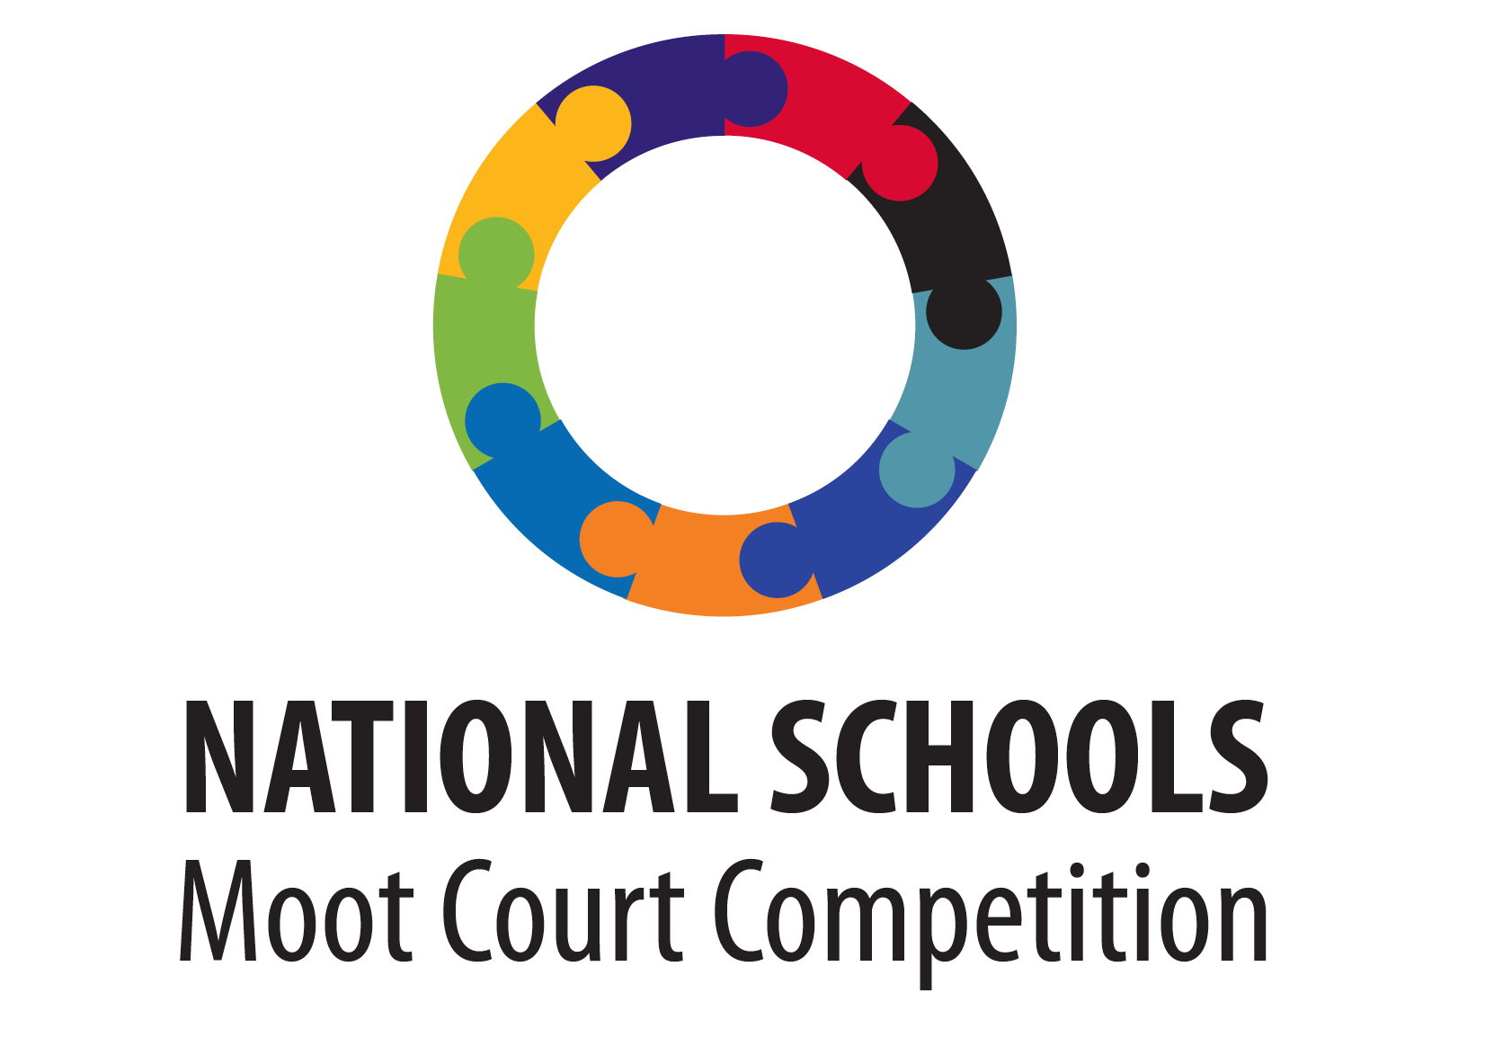
2017 Official Timeline

Release of the Hypothetical Case and Resource Pack: 16 January 2017

Release of the 2017 Official Rules 16 January 2017

EssaysSubmission Deadline 28 July 2017
With Official Cover Page Attached:

Announcement of the teams selected to participate in the 19 August 2017

Provincial Oral Rounds: 19 Aug to 2 Sep
(Dates to be confirmed by the provincial DbE/DoJ)

National Oral Rounds Arrival and Opening: 4 October 2017

Preliminary Rounds: 5 October 2017

Semi-Final Rounds: 6 October 2017

Excursion: 7 October 2017

Grand Final Oral Round: 8 October 2017

Departure: 8 October 2017

Essays must be submitted directly to the University of Pretoria to schoolsmoot@up.ac.za

