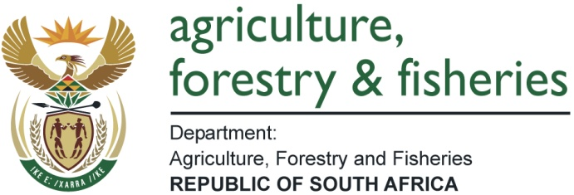
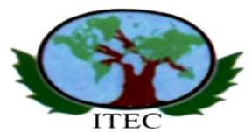

THE EGYPTIAN INTERNATIONAL CENTRE FOR AGRICULTURE
INTERNATIONAL TRAINING PROGRAMMES FOR 2018

The Department of Agriculture, Forestry and Fisheries received an invitation from the Embassy of the Arab Republic of Egypt in Pretoria to participate in the 2018International Training Programmes. These programmes are fully funded by the Egyptian International Centre for Agriculture (EICA) in Egypt. EICA will pay for international airfare (return economy airfare), training expenses, full-board accommodation, and domestic transport within the programmes, free medical care and pocket money allowance.

EICA maintains a strong network with various Research Institutions, Universities, Public and Private Sector Enterprises as well as, Tutors, Trainers, Resource Persons and Experts working in such organizations that are recruited to share their expertise with EICA participants.

The training programs are oriented in such a way to ensure coverage of the subject matter in question both from the theoretical and the practical points of view. Usually, (35 - 40%) of the total course duration is dedicated to lectures & presentations, while the remaining percentage emphasizes the practical aspects.

Requirements for admission:

- An agricultural education, at least B.Sc degree in Agriculture
- Having work experience in the field for a minimum of three years.
- Committed to continue work in the same field after the termination of the course.
- Having a good command of spoken and written English and/or French and/or Spanish.
- Healthy enough to participate actively in the course(attach medical report proving free contagious diseases)

LIST OF 2018 PROGRAMMES

No | Course Name | Duration | Start Date | End Date | Application Closing Date
1. | Food Processing | 11 Weeks | 15 January 2018 | 30 March 2018 | 31 May 2017
2. | Project Analysis | 11 Weeks | 15 January 2018 | 30 March 2018 | 31 May 2017
3. | Vegetable Production | 11 Weeks | 15 February 2018 | 30 April 2018 | 30 June 2017
4. | Agricultural Service | 11 Weeks | 11 April 2018 | 15 June 2018 | 31 July 2017
5. | Integrated Pest Management and Cotton Technology | 11 Weeks | 11 April 2018 | 15 June 2018 | 31 July 2017
6. | Poultry Production and Health | 11 Weeks | 10 July 2018 | 25 September 2018 | 31 August 2017
7. | Sustainable Rural Development | 11 Weeks | 10 July 2018 | 25 September 2018 | 31 August 2017
8. | Animal Production and Health | 11 Weeks | 1 October 2018 | 15 December 2018 | 30 November 2017
9. | Fish Culture Development | 11 Weeks | 1 October 2018 | 15 December 2018 | 30 November 2017
10 | Soil and Water Management | 11 Weeks | 1 October 2018 | 15 December 2018 | 30 November 2017

Application process:

The nominated candidates will have to complete the application and admissionformsattached to DAFF with the documents below before or /on the given deadlines:
- Detailed CV
- ID Copy
- Passport Copy
- 2 Passport size photos
- Qualifications
- A detailed medical report

Interested individuals should please send their fully completed application forms with supporting documents to:

Department of Agriculture, Forestry and Fisheries,
Directorate: Sector Education and Training
20 Steve Biko Road, Agriculture Place, VF-Block-No 16
Arcadia, Pretoria, 0001

For the attention:

Ms Jacky Smit at 012 319 7019  E-mail: JackyS@daff.gov.za | or | Mr T Makgetlane at 012 319 7159  E-mail: TshephoMa@daff.gov.za

